## DAV REPORT

## (22ADE01)

**On**

## “E-commerce Sales Analysis Project”

**Submitted in partial fulfilment for the completion of**

**BE-IV Semester**

**in**

**INFORMATION TECHNOLOGY**

**By**

**160122737110 – K. SHIVANAND**

**160122737114 – M. DEV**

**160122737136 – Y. ROHITH**

**Under the guidance of**

**Dr. N Sudhakar Yadav Sir**

**Assistant Professor,**

**Dept. of IT**



**DEPARTMENT OF INFORMATION TECHNOLOGY**

**CHAITANYA BHARATHI INSTITUTE OF TECHNOLOGY**

***(Autonomous)***

**(Affiliated to Osmania University; Accredited by NBA(AICTE) and NAAC(UGC), ISO Certified 9001:2015)**

**GANDIPET, HYDERABAD – 500075**

**Website:** [**www.cbit.ac.in**](http://www.cbit.ac.in)

**2023-2024**



**CERTIFICATE**

This isto certify that the project work entitled “**E-commerce Sales Analysis Project**” submitted to **CHAITANYA BHARATHI INSTITUTE OF TECHNOLOGY,** in partial fulfilment of the requirements for the award of the completion of DAV project (22ADE01) IV semester of B. E in Information Technology, during the academic year 2023-2024, is a record of original work done by **Y. ROHITH, M.DEV, K. SHIVANAND** during the period of study in Department of IT, CBIT, HYDERABAD, under our supervision and guidance.

**Project Guide**

**Dr. N. Sudhakar Yadav**

Asst. Professor, Dept. of IT,

CBIT, Hyderabad.

## INTRODUCTION

## Introduction to E-commerce Sales Analysis Project:

In the dynamic landscape of online commerce, businesses strive to stay competitive and relevant by leveraging data-driven insights to enhance their strategies. One of the key pillars of this approach is sales analysis, which involves the systematic examination of sales data generated by an e-commerce website. This process offers invaluable insights into consumer behavior, product performance, market trends, and overall business health.

Importance:

1. Understanding Customer Behavior: Sales analysis provides a deep understanding of customer preferences, purchase patterns, and buying habits. By analyzing data such as browsing history, cart abandonment rates, and transaction details, businesses can tailor their marketing efforts and product offerings to better meet customer needs and expectations.

2. Optimizing Product Assortment: By analyzing sales data, businesses can identify top-performing products, slow movers, and emerging trends. This insight enables them to optimize their product assortment by emphasizing popular items, discontinuing underperforming ones, or diversifying into new categories to capitalize on market opportunities.

3. Improving Marketing Strategies: Sales analysis helps businesses evaluate the effectiveness of their marketing campaigns and promotional activities. By tracking metrics such as conversion rates, customer acquisition cost, and return on investment (ROI), companies can refine their marketing strategies to maximize sales and profitability.

4. Enhancing Inventory Management: Accurate sales analysis facilitates better inventory management by predicting demand, minimizing stockouts, and reducing excess inventory. By aligning inventory levels with customer demand, businesses can improve cash flow, minimize storage costs, and enhance operational efficiency.

5. Identifying Growth Opportunities: By uncovering patterns and trends within sales data, businesses can identify untapped market segments, emerging consumer preferences, and new growth opportunities. This insight enables them to develop targeted strategies to expand their customer base, enter new markets, or launch innovative products and services.

In essence, sales analysis is the cornerstone of effective decision-making in e-commerce, empowering businesses to optimize performance, drive growth, and stay ahead in today's competitive marketplace.

**Methodology**

The requirements for a project focused on e-commerce website sales analysis would typically involve a combination of technical, analytical, and business-related aspects. Here's an outline of some key requirements:

1. Access to Data:

- Ensure access to comprehensive and accurate sales data from the e-commerce website. This includes transactional data, customer information, product details, and any other relevant metrics.

2. Data Storage and Management:

- Establish a robust data storage and management system capable of handling large volumes of sales data efficiently. This may involve setting up a database or data warehouse, ensuring data integrity, and implementing proper security measures.

3. Data Integration:

- Integrate data from various sources, such as website analytics tools, CRM systems, inventory management systems, and marketing platforms, to create a unified view of sales performance.

4. Analytics Tools and Technologies:

- Utilize analytics tools and technologies for data processing, analysis, and visualization. This may include programming languages (e.g., Python, R), data analysis libraries (e.g., Pandas, NumPy), statistical techniques, and visualization tools (e.g., Tableau, Power BI).

5. Key Performance Indicators (KPIs):

- Define relevant KPIs and metrics to measure sales performance, such as sales revenue, conversion rate, average order value (AOV), customer lifetime value (CLV), and customer retention rate.

6. Dashboard and Reporting:

- Develop interactive dashboards and reports to present sales analysis findings in a clear and actionable format. These dashboards should provide real-time or near-real-time insights into sales trends, patterns, and performance metrics.

7. Predictive Analytics:

- Implement predictive analytics models to forecast future sales trends, identify potential risks and opportunities, and support data-driven decision-making.

8. User Access and Security:

- Define user roles and permissions to control access to sensitive sales data and analytics tools. Ensure data security and compliance with relevant regulations (e.g., GDPR, CCPA).

9. Scalability and Performance:

- Design the system to be scalable and capable of handling increasing data volumes and user loads as the business grows. Optimize performance to ensure timely and responsive data analysis.

10. Collaboration and Communication:

- Foster collaboration between different teams (e.g., sales, marketing, finance) by providing access to shared insights and facilitating communication channels for discussing findings and making informed decisions.

11. Feedback and Iteration:

- Establish mechanisms for collecting feedback from stakeholders and end-users to continuously improve the sales analysis process and enhance the effectiveness of decision-making.

By addressing these requirements, the project can effectively leverage sales analysis to drive business growth, optimize operations, and enhance the overall e-commerce experience for customers.

**IMPLEMENTATION**

**The data is now ready with the following adjustments:**

These data enhancements empower e-commerce businesses to delve deeper into their sales performance metrics, unraveling patterns in customer purchasing behavior, assessing the effectiveness of promotional campaigns, and refining pricing strategies. Ultimately, leveraging these refined datasets fosters informed decision-making processes, driving revenue growth and enhancing customer satisfaction in the competitive landscape of online retail.

# **Cost and Profitability Analysis**

In the context of website sales analysis, it's essential to conduct a thorough cost and profitability evaluation to gain insights into the financial performance of the online platform. This involves examining various cost components associated with each transaction and assessing the revenue streams to determine overall profitability.

For the cost analysis, we'll focus on the following cost elements attributed to each sale:

1. Shipping Costs: The expenses incurred for delivering the products to customers.

2. Payment Processing Fees: The charges levied by payment gateways or processors for handling online transactions.

3. Discount Amount: The total value of discounts applied to orders.

To calculate the total cost per order, we'll aggregate these costs and then analyze the cumulative data to understand the cost structure across all transactions.

Revenue for the website typically comprises income generated from product sales. We'll calculate the net profit by subtracting the total costs (including discounts) from the revenue generated through product sales.

Here are the summarized metrics for the website sales analysis:

- Total Orders: 1,000

- Total Revenue (from Product Sales): [Insert Total Revenue Amount] INR

- Total Costs: [Insert Total Cost Amount] INR (including shipping costs, payment processing fees, and discounts)

- Total Profit: [Insert Total Profit Amount] INR

The analysis reveals the financial health of the website's sales operations. If the total revenue exceeds the total costs, it indicates a net profit, whereas a situation where the costs outweigh the revenue signifies a net loss. Insights gained from this analysis can guide strategic decisions regarding pricing strategies, cost optimizations, and revenue generation initiatives to enhance the website's profitability and sustainability. 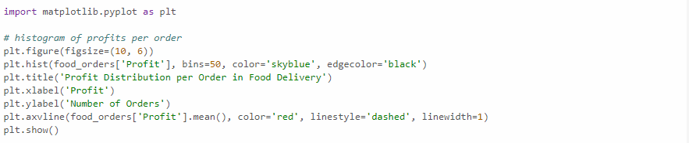

The histogram shows a wide distribution of profit per order, with a noticeable number of orders resulting in a loss (profits below 0).

The red dashed line indicates the average profit, which is in the negative territory, highlighting the overall loss-making situation.

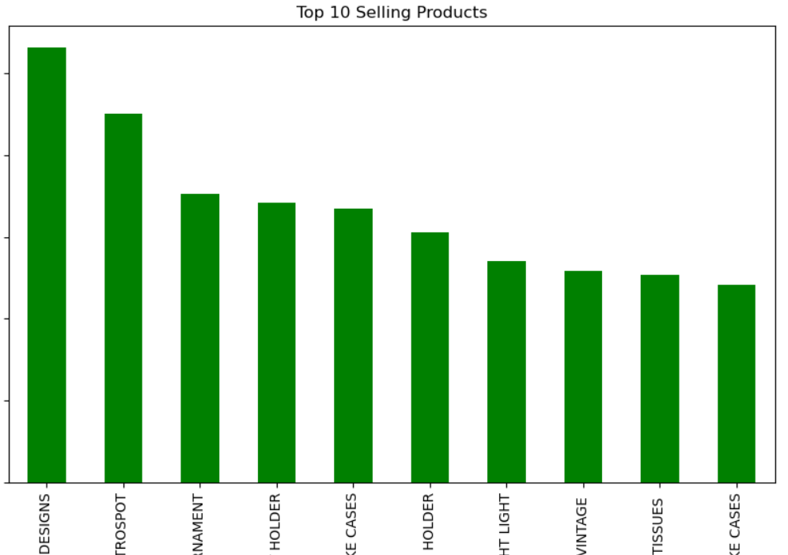

The pie chart illustrates the breakdown of total costs into delivery fees, payment processing fees, and discount amounts.

Discounts constitute a significant portion of the costs, suggesting that promotional strategies might be heavily impacting overall profitability.

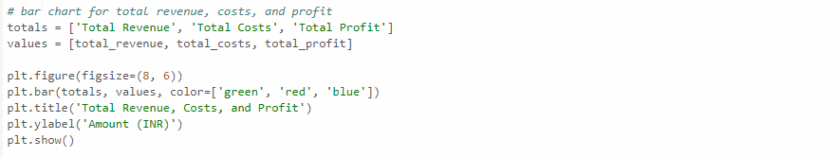

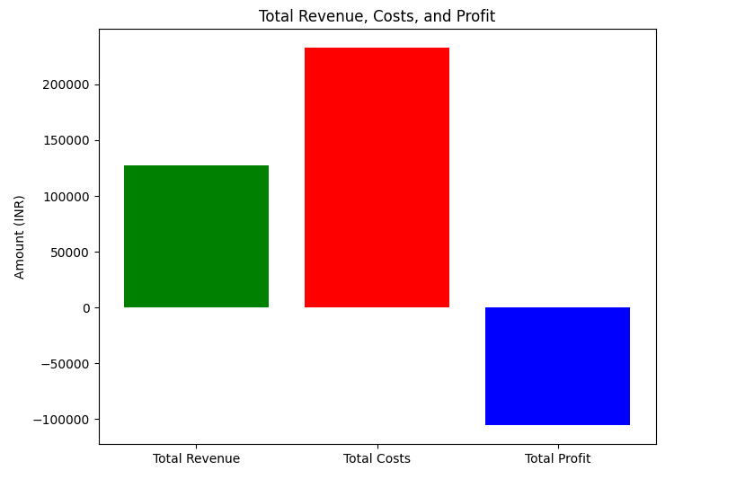

The bar chart compares total revenue, total costs, and total profit.

It visually represents the gap between revenue and costs, clearly showing that the costs surpass the revenue, leading to a total loss.

# **A New Strategy for Profits**

## To boost sales for the e-commerce website, a multifaceted strategy encompassing various aspects of marketing, customer engagement, and operational efficiency is essential. Here's a comprehensive approach:

## 1. Enhanced User Experience: Focus on improving the website's user interface and navigation to make it more intuitive and user-friendly. Ensure fast loading times, mobile responsiveness, and smooth checkout processes to reduce friction and encourage conversions.

## 2. Personalized Recommendations: Implement algorithms to provide personalized product recommendations based on customer browsing history, purchase behavior, and preferences. Tailoring recommendations can increase cross-selling and upselling opportunities, thereby boosting sales.

## 3. Targeted Marketing Campaigns: Utilize data analytics to segment customers and create targeted marketing campaigns. Leverage email marketing, social media advertising, and retargeting strategies to reach the right audience with personalized messages and promotions.

## 4. Promotions and Discounts: Offer attractive promotions, discounts, and loyalty programs to incentivize purchases and encourage repeat business. Experiment with limited-time offers, flash sales, and bundle deals to create a sense of urgency and drive sales.

## 5. Content Marketing: Develop high-quality, engaging content such as blog posts, videos, and infographics to educate and entertain your audience. Use content marketing to showcase product features, highlight customer testimonials, and address common pain points, building trust and driving conversions.

## 6. Social Proof and Reviews: Encourage satisfied customers to leave reviews and ratings, and prominently display them on product pages. Social proof and positive reviews can instill confidence in potential buyers and influence their purchasing decisions.

## 7. Optimized Product Pages: Ensure that product pages are optimized with clear, compelling product descriptions, high-resolution images, and prominent calls-to-action. Include relevant keywords to improve search engine visibility and attract organic traffic.

## 8. Expand Product Assortment: Regularly assess customer demand and market trends to identify opportunities for expanding your product assortment. Introduce new products or categories that complement existing offerings and appeal to your target audience.

## 9. Customer Support and Engagement: Provide excellent customer support through various channels such as live chat, email, and social media. Address customer inquiries promptly and resolve any issues or concerns to enhance customer satisfaction and loyalty.

## 10. Data-Driven Decision Making: Continuously monitor key performance indicators (KPIs) such as conversion rate, average order value, and customer acquisition cost. Analyze sales data to identify trends, patterns, and opportunities for optimization, and adjust your strategy accordingly.

## By implementing these strategies in a cohesive and strategic manner, the e-commerce website can effectively increase sales, attract new customers, and foster long-term growth and success.

## Market Overview

## Certainly, here's a concise market overview for the project:

## 1. Growing E-commerce Landscape: The e-commerce industry continues to expand rapidly, driven by increasing internet penetration, smartphone adoption, and shifting consumer preferences towards online shopping. Market research forecasts sustained growth in online retail sales globally.

## 2. Intense Competition: The e-commerce space is highly competitive, with numerous players vying for market share. Established giants like Amazon and Alibaba dominate the market, while niche players and startups compete by offering specialized products, unique value propositions, and exceptional customer experiences.

## 3. Rapid Technological Advancements: Technological innovations such as artificial intelligence, machine learning, and augmented reality are reshaping the e-commerce landscape. These technologies enable personalized shopping experiences, predictive analytics, and seamless integration across multiple channels, driving customer engagement and loyalty.

## 4. Shift Towards Mobile Commerce: The proliferation of smartphones has fueled the growth of mobile commerce (m-commerce), with a significant portion of online transactions now conducted through mobile devices. E-commerce platforms must prioritize mobile optimization and responsive design to cater to the increasing number of mobile shoppers.

## 5. Emerging Trends: Several emerging trends are shaping the future of e-commerce, including social commerce, subscription-based models, eco-friendly and sustainable practices, and the rise of direct-to-consumer (D2C) brands. Businesses must stay abreast of these trends and adapt their strategies to capitalize on emerging opportunities and meet evolving consumer demands.

## Cost Analysis

Introduction:

Cost analysis is crucial for understanding the financial viability and sustainability of any e-commerce project. By meticulously examining various cost components associated with each transaction, businesses can identify areas for optimization, efficiency improvements, and ultimately, profitability enhancement.

Cost Analysis for the Project:

1. Delivery Fees: Assess the expenses incurred for delivering products to customers. Analyze delivery routes, shipping methods, and carrier costs to optimize delivery processes and minimize shipping expenses.

2. Payment Processing Fees: Evaluate the charges levied by payment gateways or processors for processing online transactions. Explore options to negotiate lower transaction fees or explore alternative payment processing solutions to reduce costs.

3. Discounts and Offers: Calculate the total value of discounts provided on orders. Analyze the effectiveness of discount strategies in driving sales and customer loyalty. Determine if discounts are sustainable and if adjustments are needed to maintain profitability.

4. Operational Costs: Consider overhead expenses such as website maintenance, customer support, marketing, and fulfillment operations. Identify opportunities to streamline processes, automate tasks, or outsource non-core activities to control operational costs.

5. Profitability Analysis: Calculate the net profit by subtracting total costs, including discounts, from the revenue generated through product sales. Evaluate the project's overall profitability and assess whether adjustments are necessary in pricing strategies, cost structures, or revenue streams to achieve desired financial goals.

By conducting a comprehensive cost analysis, businesses can make informed decisions to optimize expenses, maximize revenue, and ensure the long-term success of their e-commerce project.

## Profitability Analysis

Introduction:

Profitability analysis is essential for evaluating the financial performance and sustainability of an e-commerce project. By assessing revenue streams, cost structures, and overall profitability, businesses can make informed decisions to optimize operations and maximize profits.

Profitability Analysis for the Project:

1. Revenue Streams: Evaluate the primary sources of revenue, such as product sales, subscription fees, or advertising revenue. Analyze the contribution of each revenue stream to the overall profitability of the project and identify opportunities for revenue diversification.

2. Gross Profit Margin: Calculate the gross profit margin by subtracting the cost of goods sold (including discounts) from total revenue and expressing it as a percentage. Assess the gross profit margin to determine the project's efficiency in generating profit from sales.

3. Operating Expenses: Identify and categorize operating expenses, including marketing expenses, overhead costs, and administrative expenses. Analyze the relationship between operating expenses and revenue to gauge operational efficiency and identify areas for cost reduction.

4. Net Profit: Calculate the net profit by subtracting total operating expenses from gross profit. Evaluate the net profit margin, which indicates the project's profitability after accounting for all expenses. Assess whether the net profit margin meets financial objectives and industry benchmarks.

5. Return on Investment (ROI): Assess the project's ROI by comparing the net profit generated to the initial investment or total assets employed. Determine the project's ability to generate returns relative to the resources invested and evaluate its long-term financial viability.

Conclusion:

By conducting a comprehensive profitability analysis, businesses can gain valuable insights into the financial performance of their e-commerce project. These insights enable informed decision-making, strategic planning, and continuous optimization to drive sustainable growth and profitability.

## Recommendations

Recommendations to Increase Profit through Sales Analysis:

1. Optimize Pricing Strategies: Analyze sales data to identify pricing opportunities. Consider dynamic pricing strategies based on factors such as demand fluctuations, competitor pricing, and customer segmentation. Implement pricing adjustments to maximize revenue while maintaining competitiveness.

2. Targeted Marketing Campaigns: Leverage insights from sales analysis to create targeted marketing campaigns. Segment customers based on their purchasing behavior, preferences, and demographics. Tailor marketing messages and promotions to specific customer segments to enhance engagement and drive conversions.

3. Upselling and Cross-Selling: Identify upselling and cross-selling opportunities by analyzing customer purchase patterns and product affinity. Recommend complementary products or upgrades during the checkout process to increase the average order value and maximize sales revenue.

4. Inventory Optimization: Use sales analysis to optimize inventory management processes. Identify fast-moving products and reorder them in bulk to benefit from economies of scale. Minimize excess inventory of slow-moving items by offering targeted promotions or liquidation strategies to free up capital and reduce storage costs.

5. Customer Retention Strategies: Focus on retaining existing customers through loyalty programs, personalized communications, and exceptional customer service. Analyze customer churn rates and implement retention strategies to increase customer lifetime value (CLV) and reduce customer acquisition costs. Encourage repeat purchases through post-purchase follow-ups, exclusive offers, and incentives for referrals.

By implementing these recommendations based on insights gained from sales analysis, businesses can drive profitability, enhance customer satisfaction, and achieve sustainable growth in the competitive e-commerce landscape.

**Conclusion**

In conclusion, analyzing both cost and sales data is essential for gaining a comprehensive understanding of the financial performance and operational efficiency of an e-commerce website. By examining cost components such as delivery fees, payment processing fees, and discounts, businesses can identify areas for optimization and cost reduction. Concurrently, analyzing sales data provides insights into revenue streams, customer behavior, and product performance, enabling businesses to make informed decisions to increase sales and profitability.

By integrating cost and sales analysis, businesses can:

1. Identify inefficiencies and cost-saving opportunities in operations, marketing, and logistics.

2. Optimize pricing strategies and promotional campaigns to maximize revenue and margins.

3. Enhance customer engagement and loyalty through targeted marketing and personalized recommendations.

4. Improve inventory management and product assortment to meet customer demand and minimize stockouts.

5. Drive profitability through data-driven decision-making and continuous optimization of business processes.

Overall, a holistic approach to analyzing both cost and sales data enables e-commerce businesses to achieve financial sustainability, competitive advantage, and long-term success in the dynamic online marketplace.